

**CIA4U**

**Lesson 3.1 Macroeconomic Measures and Models**

**Type of Assessment: Homework**

**Purpose of Assessment: Assessment FOR Learning**

**Method of Assessment: Yes/No**

**Learnings Goals:**

* Students will demonstrate an understanding of the business cycle model (e.g., recession, depression, peak, recovery, expansion) and various economic indicators (e.g., employment, gross domestic product, inflation).
* Students will use an aggregate demand and aggregate supply model to analyse how government macroeconomic policies can be used to achieve economic aims (e.g., low inflation, stable growth, high levels of employment).
* Students will explain how economists measure and represent standards of living and distribution of income
* Students will assess the strengths and weaknesses of various macroeconomic indicators (e.g., GDP, gross national income [GNI], consumer price index, unemployment rate).
* Students will describe alternative measures and models of economic growth and well-being that are not based on the System of National Accounts.

|  |  |
| --- | --- |
| **Macroeconomics** | D1 Macroeconomic Models and Measures: demonstrate an understanding of various macroeconomic models and measures, including indicators used to measure economic inequalities, and assess their usefulness |

|  |  |
| --- | --- |
| **Ontario Curriculum Expectations** | |
| **D1.1** | demonstrate an understanding of the business cycle model (e.g., recession, depression, peak, recovery, expansion) and various economic indicators (e.g., employment, gross domestic product, inflation) |
| **D1.2** | ​​use an aggregate demand and aggregate supply model to analyse how government macroeconomic policies can be used to achieve economic aims (e.g., low inflation, stable growth, high levels of employment) |
| **D1.3** | explain how economists measure and represent standards of living and distribution of income |
| **D1.4** | assess the strengths and weaknesses of various macroeconomic indicators (e.g., GDP, gross national income [GNI], consumer price index, unemployment rate)assess the strengths and weaknesses of various macroeconomic indicators (e.g., GDP, gross national income [GNI], consumer price index, unemployment rate) |
| **D1.5** | describe alternative measures and models of economic growth and well-being that are not based on the System of National Accounts |

**Instructions:**

For each of the following, identify the type of unemployment.

* 1. Frictional
  2. Seasonal
  3. Cyclical
  4. Structural

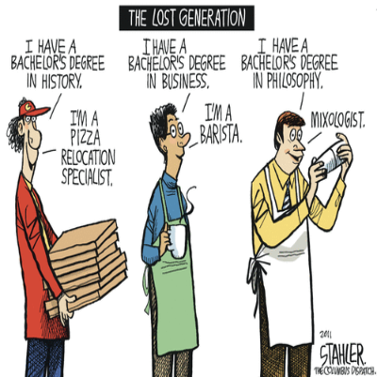

**by [Stahler](http://www.weeklystorybook.com/comic_strip_of_the_daycom/2011/10/page/3/)**

|  |
| --- |
|  |

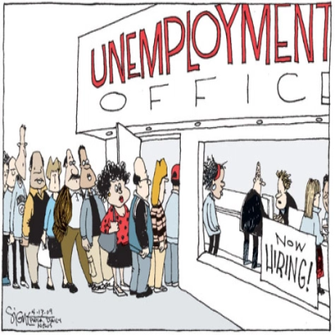

**by [Good Ole Woody's Blog and Website](https://goodolewoody.me/2013/02/01/unemployment-cartoon-3/)**

|  |
| --- |
|  |

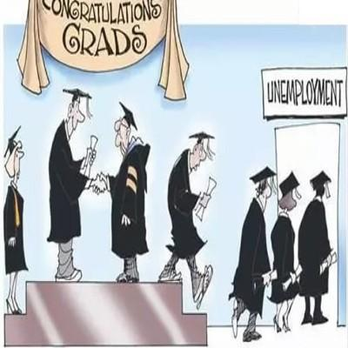

**by [Gr8AmbitionZ](https://www.gr8ambitionz.com/2017/09/essay-unemployment-in-india.html)**

|  |
| --- |
|  |



**by** [**Economics for Everyone**](http://econforeverybody.blogspot.com/2013/01/studying-unemployment-employment-for.html)

|  |
| --- |
|  |

The following income for Canada in year XX for unattached individuals. Prepare two Lorenz curves on the same graph, before and after income transfers, to demonstrate the impact on the same graph.

|  |  |  |  |  |  |
| --- | --- | --- | --- | --- | --- |
| **Population** | | **Income Share** | **Cumulative** | **Income Share With**  **Income Transfer** | **Cumulative** |
| **Lowest** | **20%** | 0.1 | 0.1 | 5.8 | 5.8 |
| **Second** | **20%** | 5.3 | 5.4 | 10.5 | 16.3 |
| **Third** | **20%** | 15.5 | 20.9 | 15.8 | 31.6 |
| **Fourth** | **20%** | 27.6 | 48.5 | 24.7 | 56.3 |
| **Fifth** | **20%** | 51.3 | 99.8 | 43.3 | 99.6 |

What are some methods governments can use to change the level of inequality? What impact do government policies have on income distribution?

|  |
| --- |
|  |

**Submit your assignment in your shared course folder.**